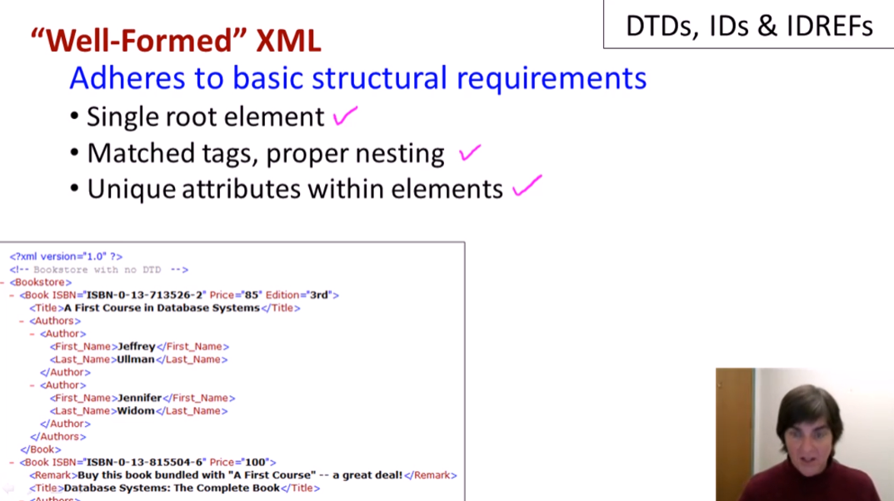

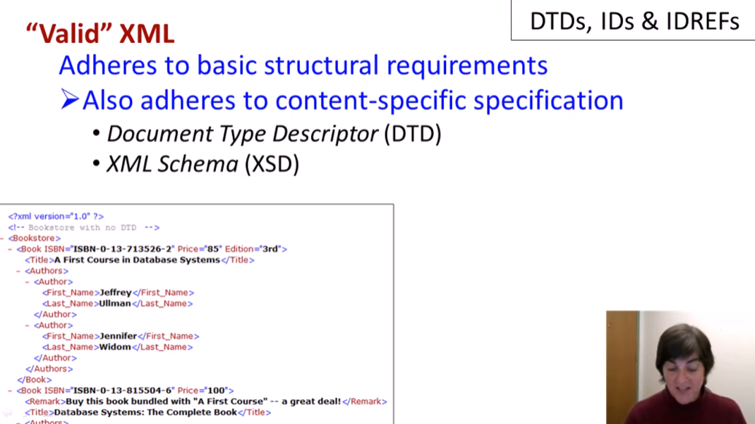

What happens with well-formed XML:

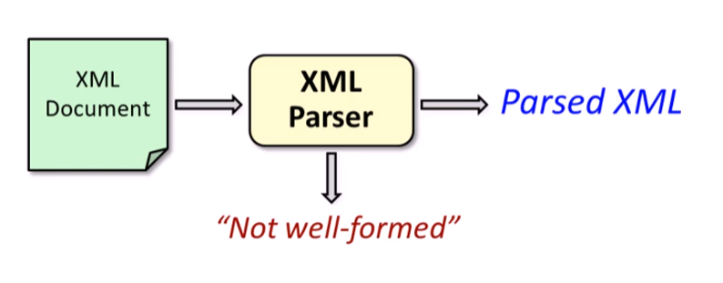

What happens with valid XML:

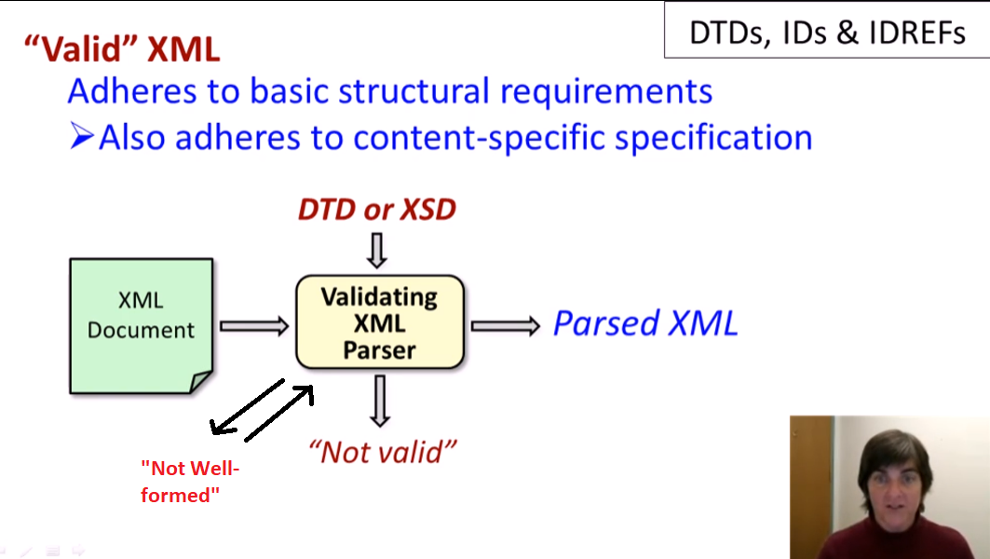

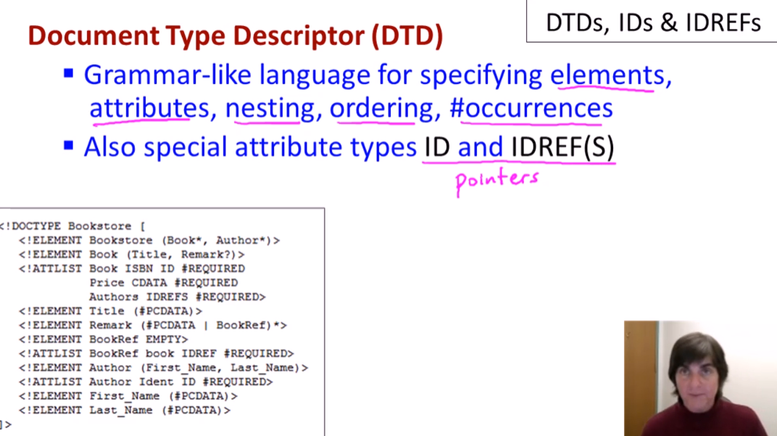

* Pointers are untyped

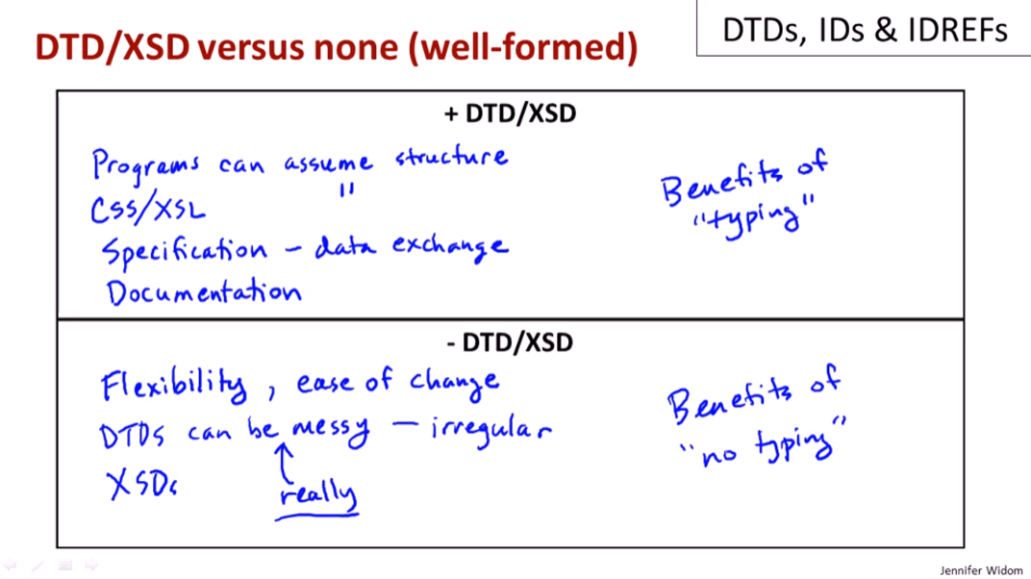

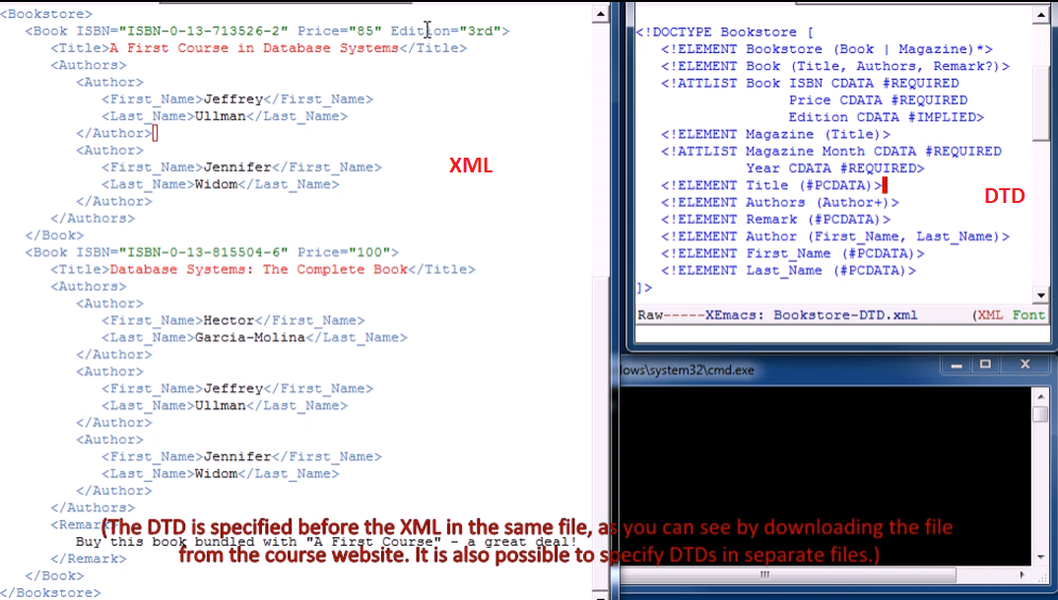

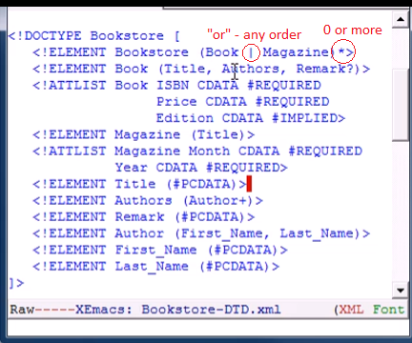

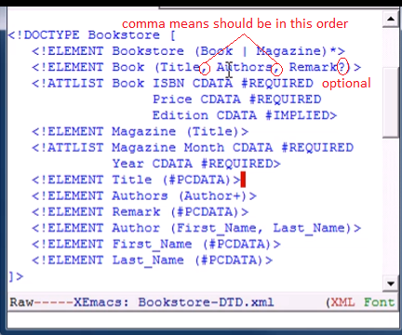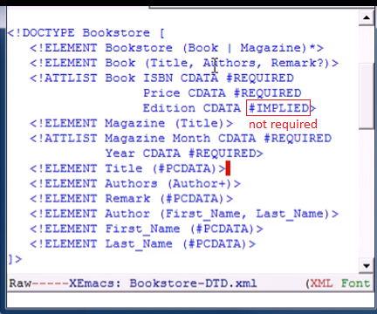

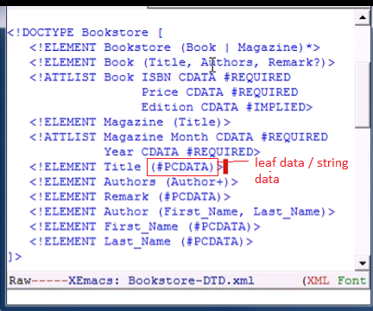

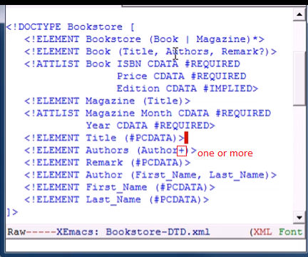

Command to check if XML is valid:

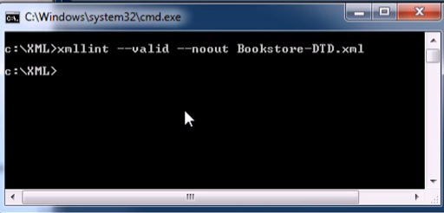

* No output means our document is correct

Editing the DTD

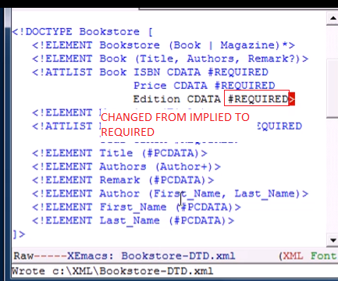

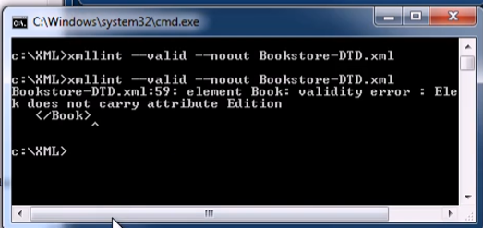

* This is because one of the books does not have edition

Adding Edition attribute to that book and running the command again:

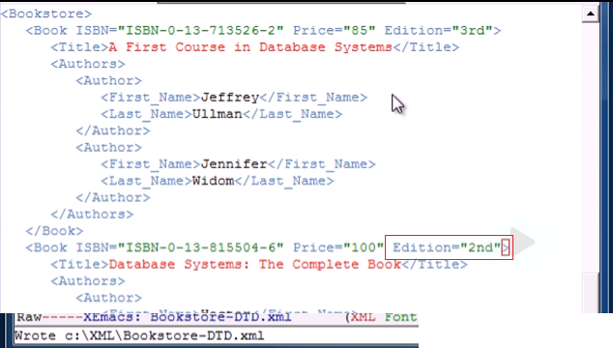

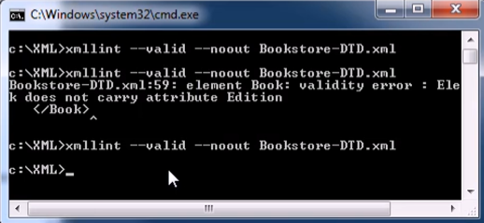

* No output - correct!

Swapping the order of last name and first name

* DTD specifies order by comma



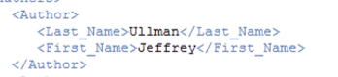

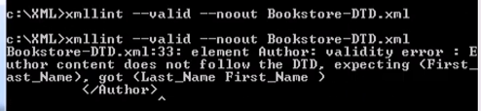

* Error! Not in the correct order

Adding Remark Element with no string data inside:

* Note that Remark element has to have PCDATA (string)







* Valid!
  + When type is PCDATA, it is perfectly valid to have an empty element

Adding Magazine Element





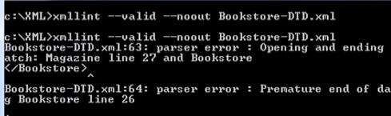

* Forgot closing tag for Magazine

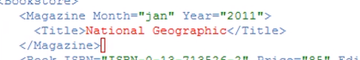



* Now valid!

Ident *ID* to Authors *IDREFS*

* ID, IDREF, and IDREFS are like types of data

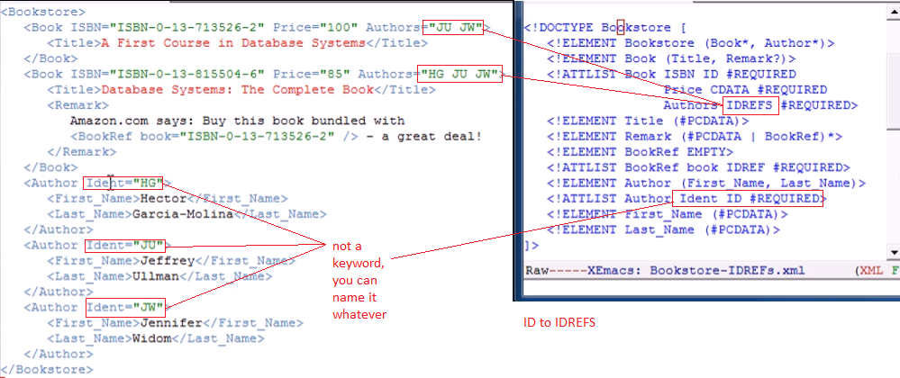

* IDREFS
  + One or more ID values separated by spaces

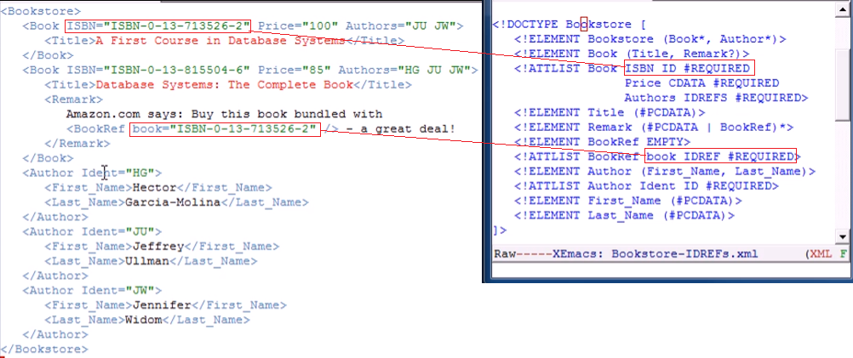

* IDREF
  + Should have exactly one value of ID

You can also mix strings and elements



Empty element (closing tag only)





Changing the ID of one author (same as the other author)

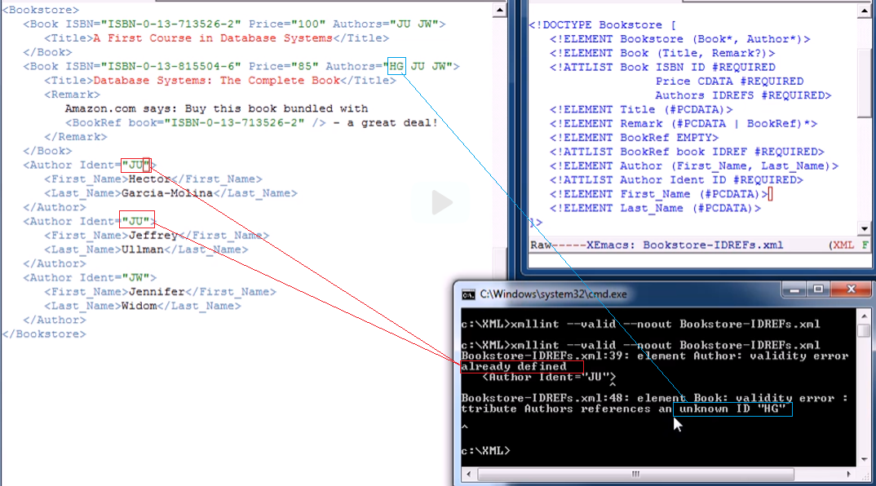

Changing the IDREF of book, referring to an ID of an author instead:

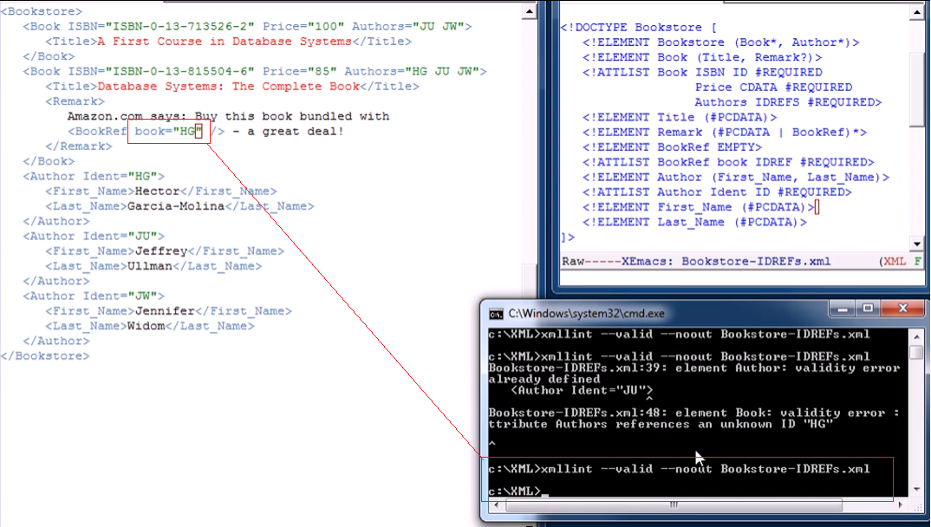

* Valid!
  + Because “HG” is still an ID type!
  + IDs have no type pointers (if ID must be a book or an author)

Mixing data:

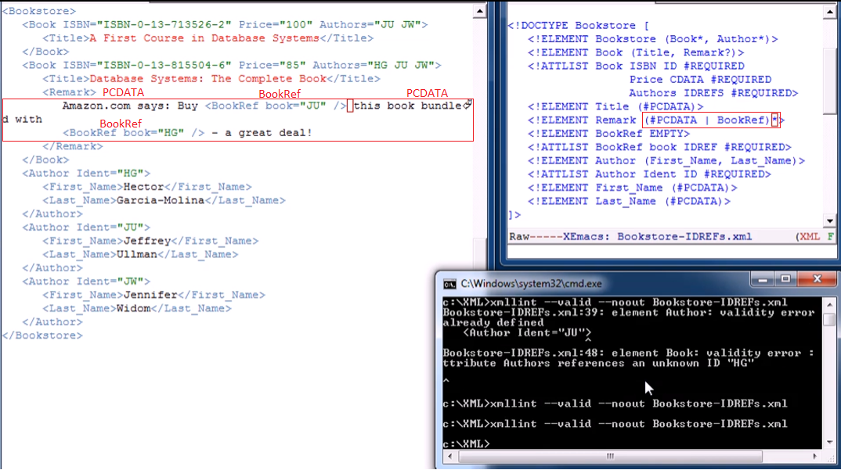

* Valid!